CHAPTER 1
INTRODUCTION

  - PROJECT DESCRIPTION
The Lung Cancer Detection System Using CNN classifies CT-Scan pictures as benign, malignant, or normal utilizing deep learning, specifically CNNs. It utilizes high-resolution imaging and intelligent automation to assist in faster and more reliable cancer diagnoses. This solution aims to minimize diagnostic errors and expedite decision-making by automatically analyzing lung scans. By training CNN models to extract critical features from medical images, the system enhances accuracy and clinical usability. Designed with scalability in mind, the interface caters to both healthcare facilities and research institutions, helping ensure early detection and improved patient outcomes.

CHAPTER 2
LITERATURE SURVEY

2.1 EXISTING AND PROPOSED SYSTEM
2.1.1 EXISTING SYSTEM
Traditional techniques for identifying lung cancer mostly depend on human analysis of CT scans and crude procedures that use machine learning features created manually. These methods are frequently laborious, ineffective, and unsuitable for a range of imaging conditions. Subjectivity and delays in diagnosis are introduced by human interpretation.

2.1.2 PROPOSED SYSTEM
The system presented in this project mitigates these challenges by applying CNNs to autonomously learn and extract features from lung CT images. It uses advanced deep learning frameworks to classify images into three categories—benign, malignant, and normal—eliminating the need for manual preprocessing. This model incorporates data normalization, layered convolutions, and dropout mechanisms to enhance both accuracy and generalization, resulting in faster and more dependable diagnostic support.

2.2 FEASIBILITY STUDY
Technical Feasibility
The system uses CNNs built on frameworks like TensorFlow/Keres, allowing high-accuracy detection of cancerous features in medical images. The application is supported by reliable tools such as PyCharm and Jupiter Notebook, and it is compatible with standard hardware configurations.

Operational Feasibility
The platform features a user-friendly interface that allows users to easily upload images and view prediction results, even with limited training. The solution aligns with current clinical workflows and simplifies the diagnostic process.

Economic Feasibility
The use of open-source technologies significantly reduces development and deployment costs. As an AI-powered system, it offers cost-saving benefits by automating routine diagnostic tasks, improving speed, and reducing dependency on manual assessments.

Legal and Ethical Feasibility
The system adheres to standard ethical guidelines in healthcare data usage. It ensures patient confidentiality and follows data privacy norms for medical records. The model only uses anonymized data for training and testing, ensuring legal and ethical compliance.

2.3 TOOLS AND TECHNOLOGIES USED
The Lung Cancer Detection System Using CNN project utilizes a diverse and powerful set of tools and technologies to support development, testing, and deployment. Visual Studio is used for initial code structuring and Windows-based setup, while PyCharm serves as the primary integrated development environment (IDE) for writing and managing Python code related to deep learning. Anaconda Navigator is employed for managing Python environments and launching Jupiter Notebooks, which are instrumental in model development, testing, and data visualization. For backend operations, XAMPP is used to locally manage services such as MySQL, which acts as the information storing database for the users, image analysis results, and generated reports. The project leverages TensorFlow and Karas to build and train the convolutional neural network (CNN) model, while Scikit-Learn is used for data preprocessing and evaluation of performance metrics. Additionally, Git and GitHub are implemented for efficient version control and team collaboration throughout the project lifecycle.
CHAPTER 3

SOFTWARE REQUIREMENTS AND SPECIFICATION

3.1 INTRODUCTION
3.1.1 PURPOSE
The objective of this SRS is to formalize and document the client’s vision for the proposed system. This document serves as a detailed blueprint that allows the client to articulate their expectations clearly, ensuring that the development team fully comprehends the necessary features and functionalities required to build the system.
This SRS is intended to guide both developers and testers in the system’s development process. The goals include fully automating the system, minimizing errors, streamlining operations to save time, centralizing database management, enhancing usability for system operators, promoting paperless operations, providing cost-efficient solutions, and delivering an intuitive GUI with context-sensitive help.

3.1.2 DOCUMENT CONVENTIONS/DEFINITIONS AND ABBREVIATIONS
- SRS: Software Requirements Specification
- SVM: Support Vector Machine
- CNN: Convolutional Neural Network
- GUI: Graphical User Interface
- HTTP: Hypertext Transfer Protocol
- DFD: Data Flow Diagram
- SQL: Structured Query Language
- RAM: Random Access Memory

3.1.3 INTENDED AUDIENCE
Developers
Developers will use the SRS to guide the implementation of system features and ensure the system aligns with specified requirements throughout development.

Administrators
Administrators will manage user access, monitor system data, maintain configuration settings, and ensure the secure and efficient operation of the platform.

Doctors
Doctors will use the system to review diagnostic predictions, download medical reports, and provide informed medical decisions based on AI-generated analysis.

Patients
Patients will use the system to upload CT-Scan images, review diagnostic predictions, download medical reports, and provide informed medical decisions based on AI-generated analysis.

3.1.4 PROJECT SCOPE:
The SRS defines the essentials for a machine learning-based Lung Cancer Detection System Using CNN that classifies CT-Scan images as malignant or benign. It will provide features such as secure login, image uploading, AI-based classification, and PDF report generation. The system is intended to improve diagnostic efficiency, accuracy, and accessibility. Administrative capabilities for managing data and maintaining system performance are also included.

3.1.5 BENEFITS
- Early and accurate detection of lung cancer
- Reduced manual diagnostic workload
- Cost-effective and scalable solution
- User-friendly web-based interface
- Reliable prediction and report generation

3.1.6 REFERENCES
- OpenCV Team.
- Research papers on Machine Learning in Healthcare
- TensorFlow and Scikit-learn documentation

3.2 OVERALL DESCRIPTION
3.2.1 IDENTIFICATION OF PRE-EXISTING WORK
Historically, lung cancer analysis was dominated by radiologist-led manual reviews and limited automation tools. These solutions often lacked scalability and were sensitive to image quality variations. Although algorithms like k-NN and Decision Trees contributed to basic classifications, they required significant manual effort. The introduction of SVMs and CNNs marked a shift towards self-learning models capable of adapting to complex image data. The outline has been built upon these advancements by integrating an end-to-end pipeline that simplifies image upload, automates prediction, and generates clinically relevant reports to support healthcare practitioners.

3.2.2 PRODUCT PERSPECTIVE
The proposed system is designed as a supportive diagnostic tool that complements existing clinical workflows. It offers a web-based interface where authorized users can securely log in, upload CT-Scan images, and receive automated predictions. The backend processes the images using AI algorithms and stores the results in a structured database. Compared to manual systems, this product significantly reduces the time needed for diagnosis and minimizes human error. It integrates modern technologies like Flask, MySQL, TensorFlow, and PDF generation to create a comprehensive, real-time solution. The system's modular design ensures easy maintainability and allows for future scalability. It is particularly suited for integration in hospitals, diagnostic labs, or telemedicine platforms where rapid and reliable diagnostic support is critical

3.2.3 PRODUCT FEATURES
- User Login and Registration: Provides secure access through role-based authentication for users and admins.
- Image Upload: Enables users to upload CT-Scan images in supported formats for processing.
- Cancer Classification: Automatically classifies uploaded images into benign or malignant using AI models.
- Report Generation: Generates downloadable PDF reports including prediction results and patient recommendations.
- Data Management: Stores user details, image metadata, and prediction history in a MySQL database.

3.2.4 END USER CHARACTERISTICS
The system is designed for use by individuals with basic computer literacy. Medical professionals are the primary users who require minimal training to operate the application. The admin users require slightly more technical understanding to manage data and users.

3.2.5 OPERATING ENVIRONMENT
The software will operate on devices with web browsers such as Chrome or Firefox. It requires Python 3.10+, MySQL, and Flask running on a local or cloud server. Basic hardware requirements include a 2.4 GHz processor, 4 GB RAM, and 10 GB free disk space.

3.2.6 DESIGN AND IMPLEMENTATION CONSTRAINTS
The system must support high-resolution CT-Scan images without significant processing delays. All modules must be implemented in Python using open-source libraries. Compatibility across Windows and Linux OS is required. Database design must enforce data integrity and security.

3.2.7 ASSUMPTIONS AND DEPENDENCIES
- Users must be authenticated to use the system.
- Reliable internet access is required for remote server access.
- Python and all required libraries should be installed and configured.
- System assumes valid image data is provided for analysis.

3.3 PRODUCT FUNCTIONALITY
3.3.1 USER MODULE
- Users can register and login to the system securely.
- Users have to upload CT-Scan images for prediction.
- The system returns a classification (benign or malignant) based on the uploaded image.
- Users can download PDF reports summarizing prediction results.

3.3.2 ADMIN MODULE
- The admin manages doctor and patient user accounts.
- Admins have the ability to add or remove users, update access permissions, and monitor system-wide activity.
- They oversee the system’s data flow and ensure platform security and maintenance.

3.3.3 DOCTOR MODULE
- Doctors can view all patient predictions and access uploaded CT-Scan images.
- They can add medical recommendations or diagnostic notes for each prediction.
- Doctors are able to track patient records over time and download or print reports as needed.

3.4 EXTERNAL INTERFACE REQUIREMENTS
3.4.1 USER INTERFACES
- The system is accessed through a modern web browser with full compatibility across popular platforms.
- The dashboard features a clean layout with dedicated panels for uploading images, viewing prediction results, and downloading PDF reports.
- It includes responsive design elements for usability across devices, along with input validation on login, registration, and file upload forms to ensure secure and correct operation.
- Clear alerts and tooltips assist users in completing each step, enhancing overall usability for patients and doctors alike.

3.4.2 HARDWARE INTERFACES
- Requires a laptop or desktop with a minimum of 2.4 GHz processor and 4 GB RAM.

3.4.3 SOFTWARE INTERFACES
- Built using Flask and Python.
- Interacts with MySQL database.
- Uses libraries like TensorFlow, OpenCV, Scikit-learn, and FPDF.

3.4.4 COMMUNICATION INTERFACES
- Uses HTTP/HTTPS protocols to communicate with the server.
- All transactions between client and server are encrypted using SSL.

3.5 OTHER NON-FUNCTIONAL REQUIREMENTS
3.5.1 PERFORMANCE REQUIREMENTS
- The overall system must provide fast and accurate responses with minimal downtime.
- The application should have built-in error checking and correction mechanisms.
- The application should be able to run efficiently even on basic internet connectivity (minimum 56 kbps bandwidth).
3.5.2 SAFETY REQUIREMENTS
- Users that are authorized can only login after successfully registering.
- Secure authentication and data protection methods must be enforced.
- User data, especially patient information and medical reports, should be securely encrypted and stored.

3.5.3 ATTRIBUTES OF SOFTWARE QUALITY
3.5.3.1 Reliability
- The system should provide consistent and accurate results in all operational conditions.
- It should function reliably across different environments and datasets.
3.5.3.2 Maintainability
- The code should be modular and well-documented to support easy upgrades and debugging.
- Maintenance activities should be low-cost and efficient.
3.5.3.3 Portability
- The system should be easily portable across various platforms without extensive reconfiguration.
- Should support standard operating systems and browsers.
3.5.3.4 Usability
- The UI must be intuitive, easy to navigate, and learnable with minimal training.
- Visual consistency and accessibility standards should be followed.
3.5.3.5 Flexibility
- The structure should be easily adaptable to new features or third-party integration.
- Should allow interaction with external APIs and medical tools.

3.6 SPECIFIC REQUIREMENTS
3.6.1 ENVIRONMENT FOR OPERATING
3.6.1.1 Hardware
- Processor: 2.4 GHz or above
- RAM: 4 GB or above
- Hard Disk: 10 GB or more free space

3.6.1.2 Software
- Front End: HTML/CSS/Bootstrap
- Back End: Python (Flask Framework)
- Database: MySQL

3.7 PLAN FOR DELIVERY
- The structure should fulfill all client requirements as outlined in the SRS.
- Each module must pass functionality and performance tests.
- Final delivery should include complete documentation, tested codebase, and deployment instructions.

CHAPTER 4

SYSTEM DESIGN

4.1 SYSTEM DESIGN
4.1.1 INTRODUCTION
System design is a crucial stage in software development. It focuses on identifying the necessary modules, defining their functions, and outlining how they interact to deliver the intended outcome. This phase transforms user requirements into specific system features. It covers both the logical framework and the physical structure of the system. The logical design outlines elements like input files, output files, and databases, ensuring they align with project goals. Overall, this process helps clarify the structure and workflows needed to successfully build and implement the system.

4.1.2 SCOPE OF THE PROJECT
- Early Detection through AI/ML: This system grips on AI or ML models to analyze patient data and detect signs of early lung cancer with maximum accuracy.
- Medical Record Management: Maintain detailed electronic records of patients, including reports, scans, and prediction results for future reference and treatment planning.
- Risk Prediction: Enables this system to predict the probability of having lung cancer based on various risk factors such as age, family history, genetic information, and other medical conditions.
- Doctor-Patient Interaction: Facilitate communication between doctors and patients for consultations, recommendations, and follow-up appointments through the platform.
- Admin Control Panel: Provides executive features for user management (patients and doctors), reviewing prediction logs, and overseeing system operations.
- User-Friendly Interface: Ensures this system is easily accessible and easy to access and use for patients and healthcare professionals with minimal technical knowledge.
- Data Security & Privacy: Implement strong authentication and encryption to secure patient data in consideration with health data protection standards.
- Scalability & Integration: Design the system in a way that it can be integrated with existing hospital or clinic systems and scaled for larger user bases or additional diagnostic features.

4.1.3 INTENDED AUDIENCE
The intended users of the Lung Cancer Detection System Using CNN are the participants who are supposed to accompany with the application to perform specific roles that contribute to early diagnosis and medical decision-making. This detection system is designed to serve three primary user groups: Admins, Doctors, and Patients. Each user plays a distinct role in ensuring the effectiveness of the system
Admin
- Manage system operations, oversee user accounts, and maintain data integrity.
- Monitor model performance and ensure compliance with data policies.

Doctor
- Access patient history and diagnostic predictions.
- Analyze AI-generated reports and guide patients accordingly.
- Input clinical data and review past consultations.

Patient
- Register and update personal medical information.
- Submit diagnostic data for early detection analysis.
- View prediction results and consult with doctors through the system.

4.1.4 CONTEXT FLOW DIAGRAM

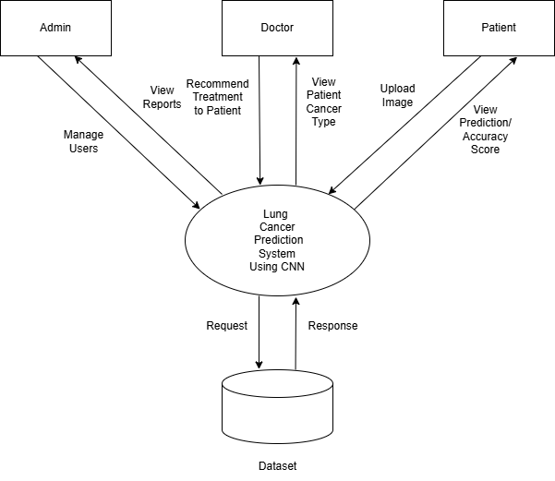
Fig 4.1: Context Flow Diagram of Lung Cancer Detection System Using CNN

4.1.5 ADMIN DFD

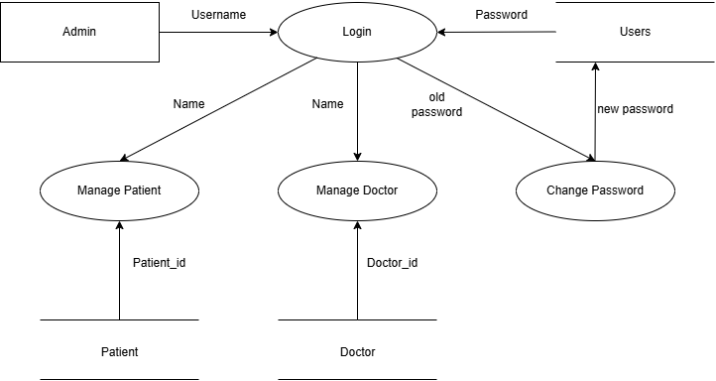

Fig 4.2 Admin DFD

4.1.6 DOCTOR DFD

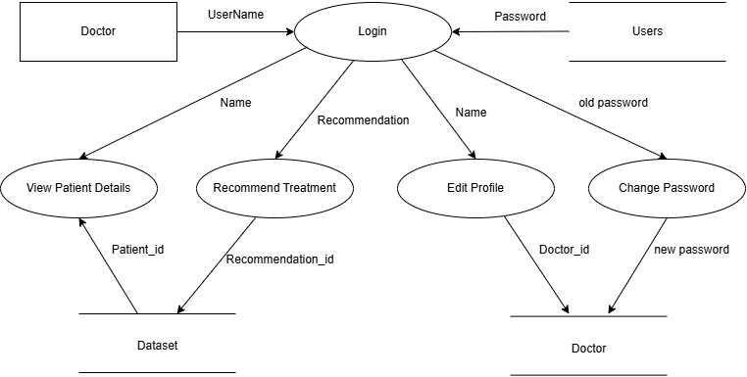

Fig 4.3 Doctor DFD

4.1.7 PATIENT DFD

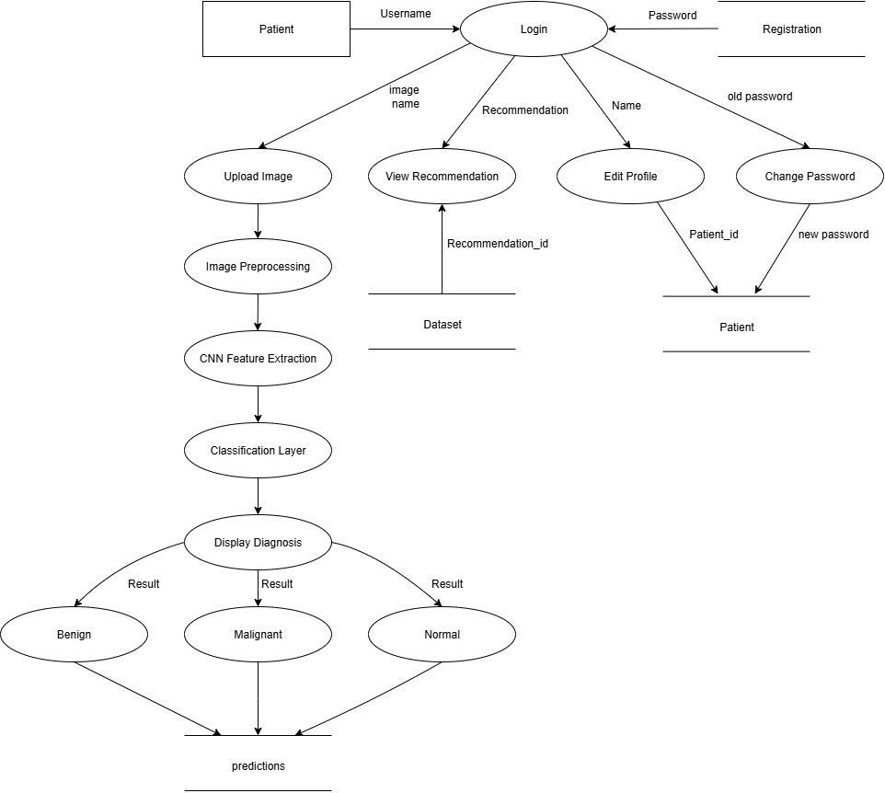

Fig 4.4 Patient DFD

CHAPTER 5

DETAILED DESIGN

5.1 USE CASE DIAGRAM
Diagram for use case of the Lung Cancer Detection System Using CNN graphically represents the communication of Actors i.e. Admin and Users, dealing with the system.
System: The system is depicted as a rectangle which is nothing but an activity for detection system for lung cancer.
The Actor: An Actor is viewed as a stick man. They represent Users as well as Admin.
The use case: The operations carried out on the System activity, is represented by the oval shape.
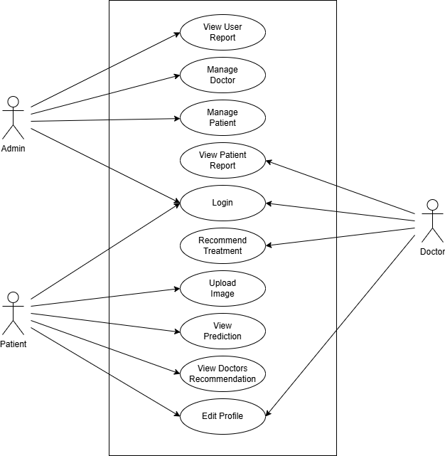

Fig 5.1 Use Case Diagram of Lung Cancer Detection System Using CNN
5.2 SEQUENCE DIAGRAM
A sequence diagram illustrates how things communicate with one another over time. It is employed to demonstrate how the things communicate with one another and exchange messages. Another name for a sequence diagram is an event diagram.

5.2.1 ADMIN SEQUENCE DIAGRAM

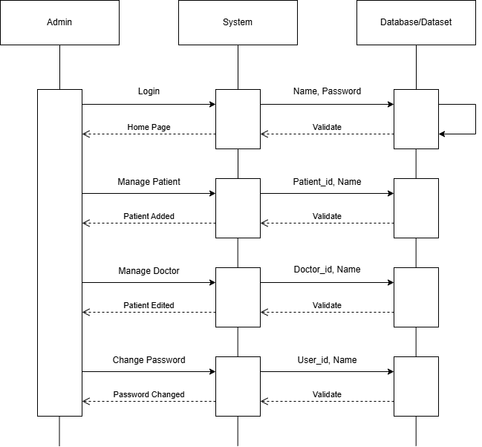
Fig 5.2 Admin Sequence Diagram

5.2.2 DOCTOR SEQUENCE DIAGRAM
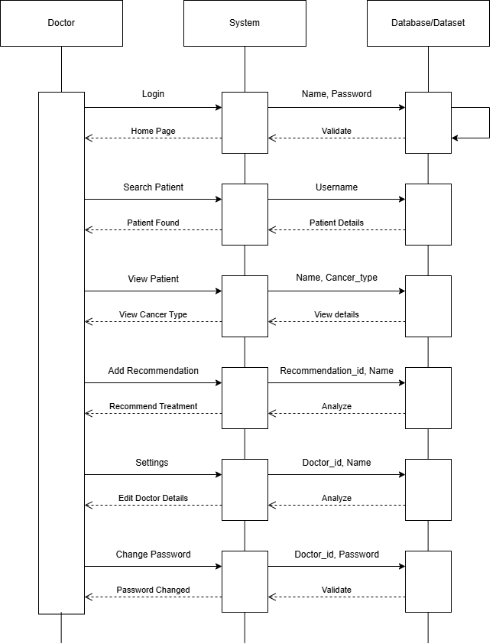
Fig 5.3 Doctor Sequence Diagram

5.2.3 PATIENT SEQUENCE
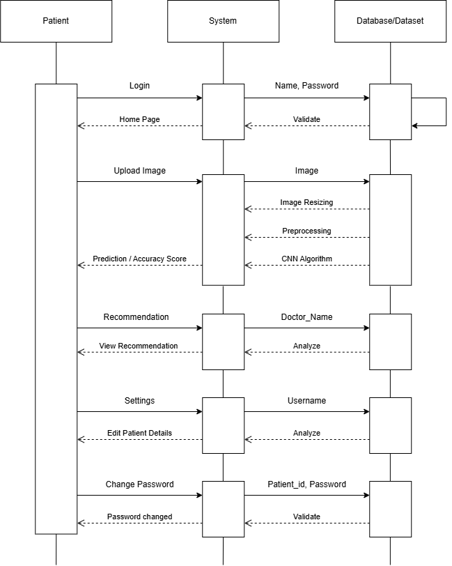
Fig 5.4 Patient Sequence Diagram

5.3 ACTIVITY DIAGRAM
One kind of flowchart that illustrates how one activity leads to another is an activity diagram. The activity's flow is sometimes referred to as the system's process or how it operates.

5.3.1 ADMIN ACTIVITY DIAGRAM

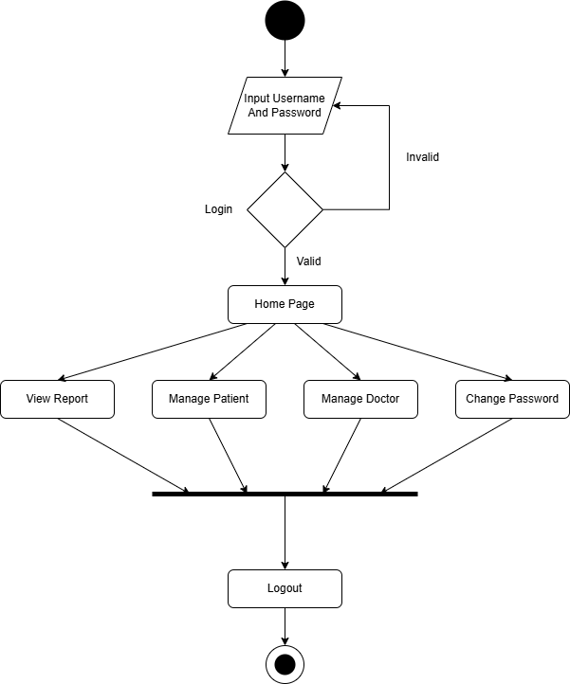
Fig 5.4 Admin Activity Diagram

5.3.2 DOCTOR ACTIVITY DIAGRAM
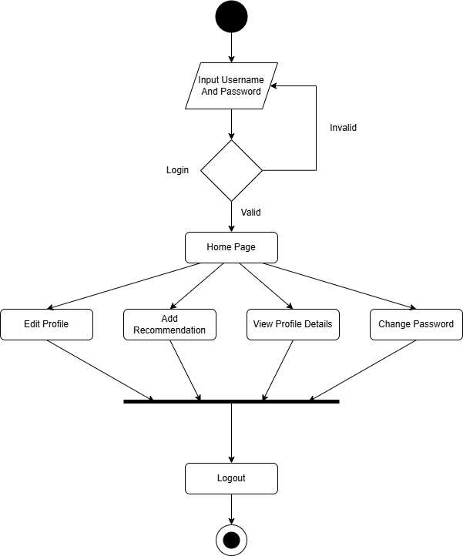

Fig 5.5 Doctor Activity Diagram

5.3.3 PATIENT ACTIVITY DIAGRAM

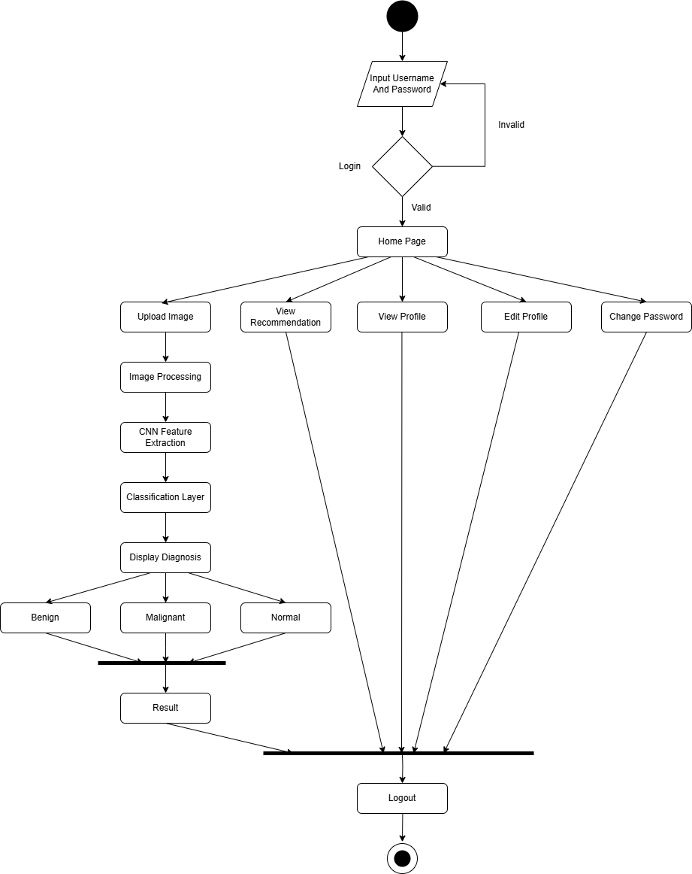
Fig 5.6 Patient Activity Diagram
5.4 DATABASE DESIGN
Table 5.1: USERS
Attributes | Data Types | Constraint | Descriptions
user_id | INT(11) | PRIMARY KEY, AUTO_INCREMENT | each user has a different identifier
username | VARCHAR(50) | NOT NULL | Full name of the user
email | VARCHAR(50) | NOT NULL, UNIQUE | User's login email
password | VARCHAR(255) | NOT NULL | Hashed password
role | ENUM | ('patient', 'doctor', 'admin'), NOT NULL | Role assigned to the user
created_at | TIMESTAMP | DEFAULT CURRENT_TIMESTAMP | Account creation timestamp

Table 5.2: ADMINS
Attributes | Data Types | Constraint | Descriptions
admin_id | INT(11) | PRIMARY KEY, AUTO_INCREMENT | Unique identifier for admin
user_id | INT(11) | FOREIGN KEY (users.user_id) | Associated user ID
admin_name | VARCHAR(50) | NOT NULL | Admin’s full name
phone | VARCHAR(15) | NOT NULL | Admin’s contact number
address | VARCHAR(100) | NOT NULL | Admin’s address

Table 5.3: DOCTORS
Attributes | Data Types | Constraint | Descriptions
doctor_id | INT(11) | PRIMARY KEY, AUTO_INCREMENT | Unique identifier for each doctor
user_id | INT(11) | FOREIGN KEY (users.user_id) | Linked user ID
doctor_name | VARCHAR(50) | NOT NULL | Full doctor’s name
speciality | VARCHAR(50) | NOT NULL | Doctor’s specialization (e.g., Oncologist)
phone | VARCHAR(15) | NOT NULL | Doctor’s contact number
address | VARCHAR(100) | NOT NULL | Clinic or residence address
gender | ENUM | ('Male','Female','Other'), NOT NULL | Gender of the doctor

Table 5.4: PATIENTS
Attributes | Data Types | Constraint | Descriptions
patient_id | INT(11) | PRIMARY KEY, AUTO_INCREMENT | Unique patient identifier
user_id | INT(11) | FOREIGN KEY (users.user_id) | Linked user ID
patient_name | VARCHAR(50) | NOT NULL | Full patient’s Name
DOB | DATE | NOT NULL | Date of birth
Gender | ENUM | ('Male','Female','Other'), NOT NULL | Gender of the patient
Phone | VARCHAR(15) | NOT NULL | Contact number
Address | VARCHAR(100) | NOT NULL | Patient’s residential address
blood_type | VARCHAR(10) | NOT NULL | Blood group
Table 5.5: PREDICTIONS
Attributes | Data Types | Constraint | Descriptions
prediction_id | INT(11) | PRIMARY KEY, AUTO_INCREMENT | Prediction has a Unique ID
user_id | INT(11) | FOREIGN KEY (users,user_id) | User associated with the prediction
Filename | VARCHAR(100) | NOT NULL | File name of the uploaded CT-Scan image
predicted_class | VARCHAR(50) | NOT NULL | Output class (e.g., benign, malignant, normal)
confidence_scores | TEXT | NOT NULL | JSON-formatted confidence probabilities
image_path | VARCHAR(255) | NOT NULL | Path to the stored image
recommendation | TEXT | NULLABLE | Doctor’s recommendation is given on the prediction
Timestamp | TIMESTAMP | DEFAULT CURRENT_TIMESTAMP | Date, time of prediction

5.4.1 ER-DIAGRAM
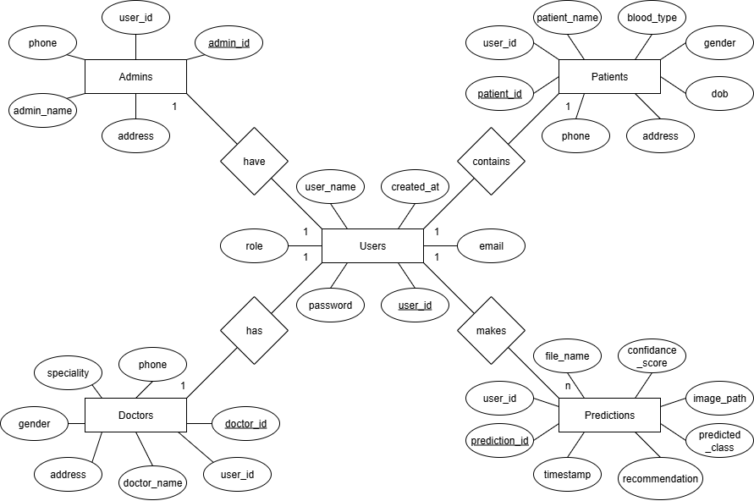
Fig 5.7 E-R Diagram
CHAPTER 6:
IMPLEMENTATION
6.1 INTRODUCTION
Executing a plan is the process of implementation. It involves an overview, a brief description, and the tasks required to carry out the implementation. During this phase, various test cases are evaluated and integrated into the system.
Adhering to coding standards is crucial as this step ensures that the code is organized and comprehensible, even to those who are not the original developers. This facilitates easier maintenance, as others can modify or upgrade the system if needed. The conventions used for naming are consistent with those of Windows classes.
6.2 PSEUDO CODE
6.2.1 PSEUDO CODE FOR REGISTRATION PAGE:
Users must register with the system by using their email ID, name, contact number, password, and confirming the password. If the provided data is valid, a message will display: "Registration successful."
Begin
Input: Name, Email ID, Contact Number, Password, Confirm Password
Verify that all the required fields are filled and the data is valid.
If the data is valid:
Update the database
Display "Registration successful"
Else:
Message for error is displayed
End
6.2.2 PSEUDO CODE FOR LOGIN PAGE
Users must log in with their registered email id and password. If the email id is found, verify if the password matches. If the password is correct, the login is successful; otherwise, an error message will be displayed.
Begin
Input: Email, Password
Validate if both email and password is filled and the data is correct.
If Email and Password are valid:
Call check User Type()
If the type of user is admin:
Navigate to Dashboard()
Else if:
Navigate to Home()
Else:
Message for error is displayed
End

6.2.3 PSEUDO CODE FOR LUNG CANCER DETECTION
Begin
Input: High-resolution CT-Scan images
Preprocess the images:
Apply normalization
Perform noise reduction
Apply contrast enhancement
Standardize image size and resolution
Extract features:
Identify texture, shape, density, and cancer size
Analyze using CNN features:
Classify the type of cancer based on trained dataset
If cancer is malignant:
Recommend further medical evaluations and treatment
Else if cancer is benign:
Suggest routine monitoring and preventive measures
End

6.3 CNN ALGORITHM DETAILS
In this hybrid 2x2 CNN architecture, the initial convolutional layers progressively extract low-level to high-level features such as edges, textures, and patterns crucial for distinguishing medical anomalies. The increasing number of filters (from 32 to 64) enables deeper extraction of features, capturing global and local spatial hierarchies relevant to CT scan images. The use of ReLU activation introduces non-linearity, allowing the replica to learn complex patterns effectively. Max-Pooling layers reduce the spatial dimensions and computational load, enhancing the network’s translational invariance. After flattening, the 128 dense layer neurons act as a high-level classifier that integrates extracted features. Dropout with a rate of 0.5 helps prevent overfitting by randomly disabling half of the neurons during training, promoting generalization. The final SoftMax activation outputs a normalized probability distribution across the three classes—benign, malignant, and normal—ensuring interpretability in medical diagnosis. The Adam optimizer dynamically adjusts learning rates during training, leading to faster convergence, while the sparse categorical cross-entropy loss is particularly suitable for multi-class classification with integer labels. The model has been trained for 100 epochs with an 80:20 train-validation split to ensure adequate learning while preventing overfitting, making the architecture well-suited for medical image classification tasks.

6.4 ACCURACY ASSESSMENT
For prediction, input CT scans are read using OpenCV, resized to 224×224 pixels, normalized to a 0–1 scale, and reshaped for model compatibility. The processed image is fed into the trained CNN, which outputs probability scores via SoftMax. The highest score determines the predicted class, while the associated value signifies the model’s confidence. This ensures transparency and easy interpretation for medical professionals.
CHAPTER 7
SOFTWARE TESTING
7.1 SOFTWARE TESTING INTRODUCTION
Testing, a crucial procedure used to guarantee the accuracy, comprehensiveness, and caliber of software. By locating and fixing software bugs, it contributes significantly to a system's success. Finding flaws so they can be fixed is testing's main objective. To make sure the user requirements are satisfied, this outline is assessed against them using different types of validations and tests. Both unit and integration testing are done, and users who are not amicable with the software evaluate the system to check if it performs as intended. Determining test conditions, producing test data, and scheduling predicted vs actual outcomes are all steps in the testing process. Individual components are evaluated first, and then the overall system is thoroughly tested.

7.2 TESTING OBJECTIVES
- Ensure the software links up to the requirements and is designed accordingly.
- Improve software quality, see that this system is error-free.
- Verify all the necessary verifications and validations are completed.
- Verify that each module is carried out in line with the specification.
The testing for this project includes Unit Testing and Integration Testing. The details of implementing each module are outlined below.

7.3 UNIT TESTING
Unit testing, sometimes referred to as section testing, is the task of analyzing certain code segments, usually at the useful level. To confirm that every function operates as intended, programmers or developers typically see to it that these tests during the coding stage. In order to minimize risks, shorten development times, and cut expenses, unit testing is essential for preventing and identifying flaws. Verifying that every software unit performs as per the main goal of unit test stage. A unit, which often has one or a few inputs and a single output, is the smallest testable feature of the software.

7.3.1 UNIT TEST CASES
Assessing an application's smallest testable components is called unit testing. Detection for Error and correction at this point is simple, effective, and economical. To see that it generates the desired results, each part in this project is tested separately using appropriate inputs.

7.3.2 TESTING IF THE USER’S NAME IS VALID

Table 7.1: Testing if the user’s name is valid
Test Cases | Inputs Given | Description of the Test | Output
1 | Username already exists | Duplicate Username cannot be used | User named previously exists
2 | User name field is null | name field cannot be empty | Entering the name is mandatory

7.3.3 TESTING IF PASSWORD IS VALID

Table 7.2: Testing if password is valid
Test cases | Inputs Given | Description of the Test | Output
1 | Password field is left empty | Password field cannot be empty | Entering password is mandatory
2 | Password used is not valid | A valid password should be used | Mismatched password is detected

7.3.4 TESTING IF INSERTION OF DATA IS VALID

Table 7.3: Testing if insertion of data is valid
Test cases | Inputs Given | Description of the Test | Output
1 | Required area is null | Not allowed to leave mandatory fields empty | Must enter data
2 | Entry of duplicate data | Entry of duplicate data is not allowed | Displays error
3 | Inputs lacking the above mistakes | Input is Valid | Successfully inserted record

7.3.5 TESTING FOR REGISTRATION

Table 7.4: Testing for registration
Tests cases | Inputs Given | Description of the Test | Output
1 | If any field found empty | Each value must be filled. | All values must be entered.
2 | Username is Text | Valid username needed to be entered | Enter genuine username
4 | If Password is blank | Password is empty | Enter the password
5 | Password Confirmation  does not congruent | The right password should be used | Mismatched password is detected
6 | Valid input | Valid input | Registrations successful

7.3.6 TESTING FOR DATA

Table 7.5: Testing for data
Tests cases | Inputs Given | Description of the Test | Output
1 | Image | Data should be in JPEG/JPG/PNG format. | Data will be retrieved
2 | Image | Format is invalid | Error is thrown

7.3.7 ANALYSIS TESTING

Table 7.6: Testing for Analysis
Tests cases | Inputs Given | Description of the Test | Output
1 | analysis | The Model should be loaded | If proper model not selected it may throw any error

7.3.8 TESTING FOR FORM

Table 7.7 Testing for Form
Test cases | Inputs Given | Description of the Test | Output
1 | Form | Each value must be entered. | An error will be thrown if not selected.

7.4 INTERGRATION TESTING
Assessing an application's smallest testable components is called as unit testing. Detection for error and correction at this point is simple, effective, and economical. To see that it generates the desired results, each part of this project is tested separately using appropriate inputs. Verifying the interfaces and interactions between components in line with the software design is the primary goal of integration testing, a software testing methodology. Integration testing is beneficial in this outline since it facilitates the rapid identification and isolation of interface problems. It seeks to identify flaws in the way integrated modules interact with one another. Larger and larger groupings of tested components that are in line with the architectural design are united and evaluated as testing goes on until the program works as a single unit.
7.4.1 TEST CASES FOR INTEGRATION TESTING

Table 7.8: Integration Test Cases for Data Insertion

Test cases | Inputs Given | Descriptions of the Test | Output
1 | Required  fields are not packed out | Mandatory fields  must not be left blank | Displays an  error message as expected
2 | A duplicate entry is provided | Duplicate entries should be disallowed | Displays an error message as expected
7.4.2 OTHER CASES:

Table 7.9: Integration Test Cases for Other Cases
Test cases | Inputs Given | Description of the Test | Output
1 | Click on exit | The application closes | Application will close
2 | Click on clear | While entering details | The data is not entered to the database, and text fields are cleared
3 | On save | After entering details | The details are entered into to the database
4 | On save | Without entering  details | A relevant error is displayed
5 | 87376842 | Entering numbers in the place of letters | Characters will not be displayed
6 | Drop Down is Clicked | Data Selecting | Data will be shown

CHAPTER 8
CONCLUSION

The Lung Cancer Detection project utilizing Convolutional Neural Networks (CNNs) marks significant progress in medical diagnostics by applying the learning techniques to classify CT scan images into benign, malignant, or normal categories. The CNN-based model addresses the shortcomings of traditional manual analysis and rule-based systems, offering a scalable and highly accurate approach for early detection of lung cancer.
With a user-friendly interface and harmonious performance across different datasets, the system improves the overall diagnostic process for doctors, patients, and healthcare staff. Its design integrates automated preprocessing, real-time predictions, and structured result generation, making it practical and dependable in clinical use.
Beyond aiding in early detection, this solution highlights the possible of AI-driven healthcare tools. It demonstrates how technology can play a crucial role in enabling faster decisions and more efficient patient care, contributing meaningfully to the fight against lung cancer.

CHAPTER 9
FUTURE ENHANCEMENTS

Future upgrades to the Lung Cancer Detection System Using CNN could include real-time image analysis and integration with live imaging tools, such as portable ultrasound devices or IoT-enabled CT-Scan equipment. Expanding the platform with multilingual support would make it more accessible in diverse regions and healthcare settings.
To boost accuracy and interpretability, the system could use advanced ML techniques like ensemble methods or transformer-based models. A shared portal for medical professionals to annotate images, exchange insights, and contribute to a central diagnostic database would further encourage collaboration.
Adding features like patient feedback options and automated follow-up reminders could enhance care after diagnosis. Regular updates using the latest datasets and adherence to global medical standards will help the system stay accurate, effective, and clinically relevant over time.

APPENDIX A
REFERENCES

[1] Krizhevsky, A., Sutskever, I., & Hinton, G. E. (2017). ImageNet Classification with Deep Convolutional Neural Networks. Communications of the ACM, 60(6), 84–90. https://doi.org/10.1145/3065386
[2] Chollet, F. (2021). Deep Learning with Python (2nd ed.). Manning Publications.
[3] Abdel-Basset, M., Hawash, H., & Chakrabortty, R. K. (2022). Lung cancer diagnosis using deep learning techniques. Medical Image Analysis. https://doi.org/10.1016/j.media.2021.102137
[4] TensorFlow Developers. (n.d.). TensorFlow: An End-to-End Open Source Machine Learning Platform. Retrieved from https://www.tensorflow.org
[5] Scikit-learn Developers. (n.d.). Scikit-learn: Machine Learning in Python. Retrieved from https://scikit-learn.org/stable/
[6] OpenCV Team. (n.d.). Open Source Computer Vision Library. Retrieved from https://opencv.org
[7] Flask Documentation. (n.d.). Flask: Python Web Framework. Retrieved from https://flask.palletsprojects.com
[8] Kaggle. (n.d.). Lung CT Scan Image Dataset for Classification. Retrieved from https://www.kaggle.com
[9] American Cancer Society. (n.d.). Lung Cancer Early Detection. Retrieved from https://www.cancer.org
[10] Younas, R., Khan, M. A., Saba, T., & Tariq, U. (2023). An attention-based deep learning model for early detection of lung cancer in CT scans. Computers in Biology and Medicine, 157, 106735. https://doi.org/10.1016/j.compbiomed.2023.106735

APPENDIX B
SCREENSHOTS
REGISTRATION PAGE
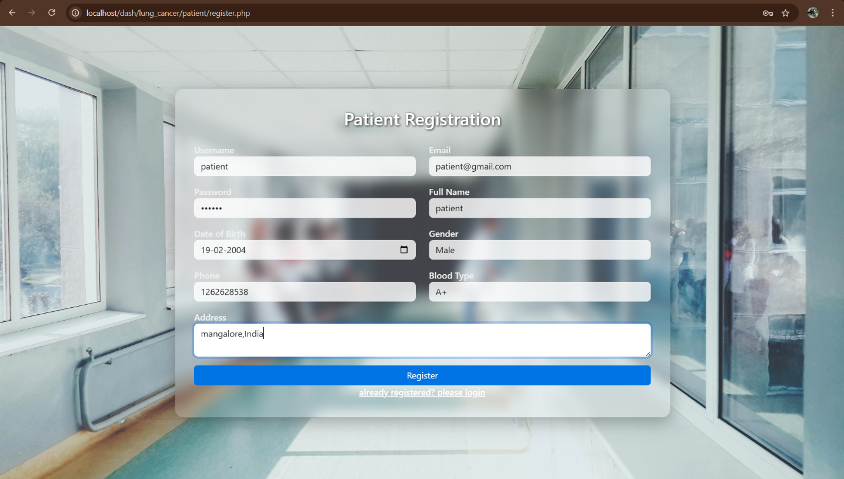
LOGIN PAGE
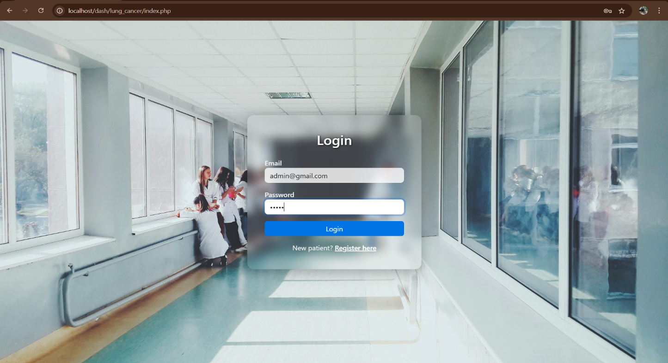
LOGIN ERROR
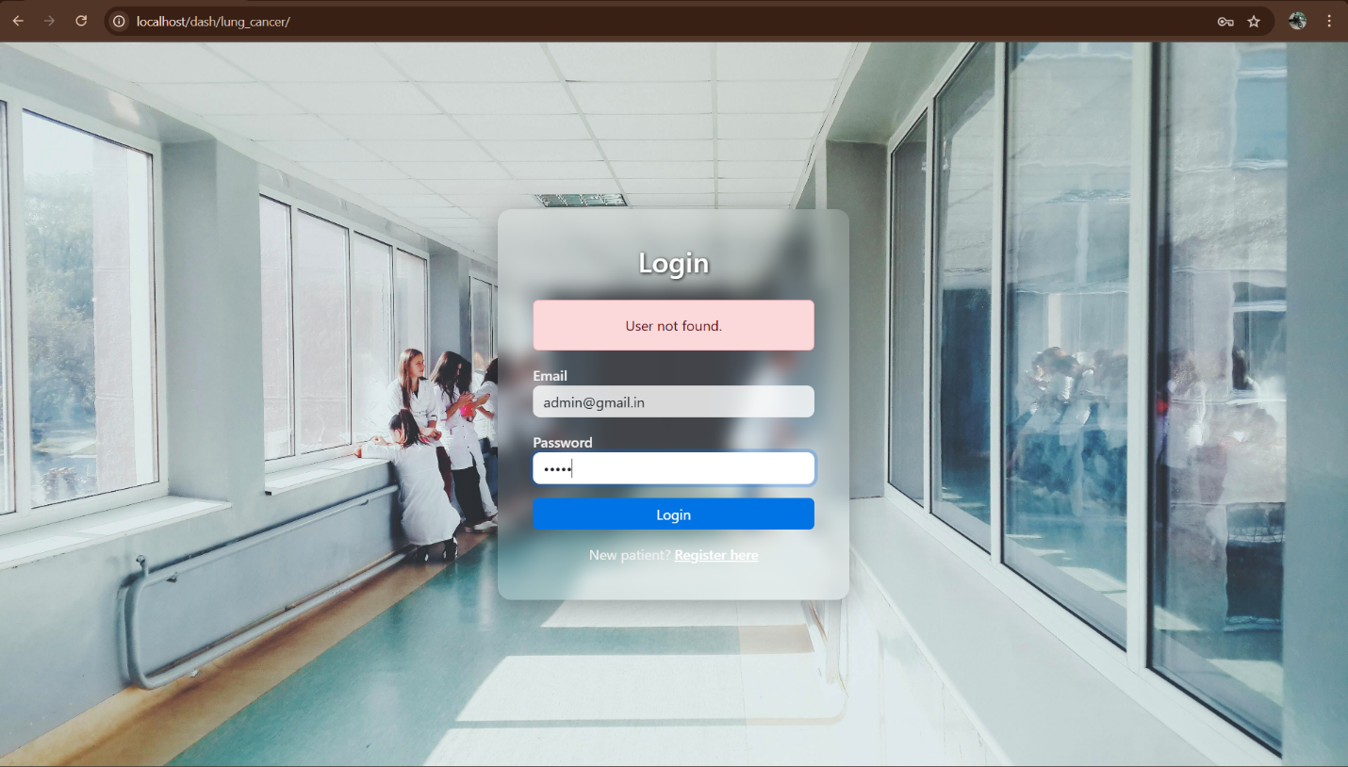

ADMIN DASHBOARD
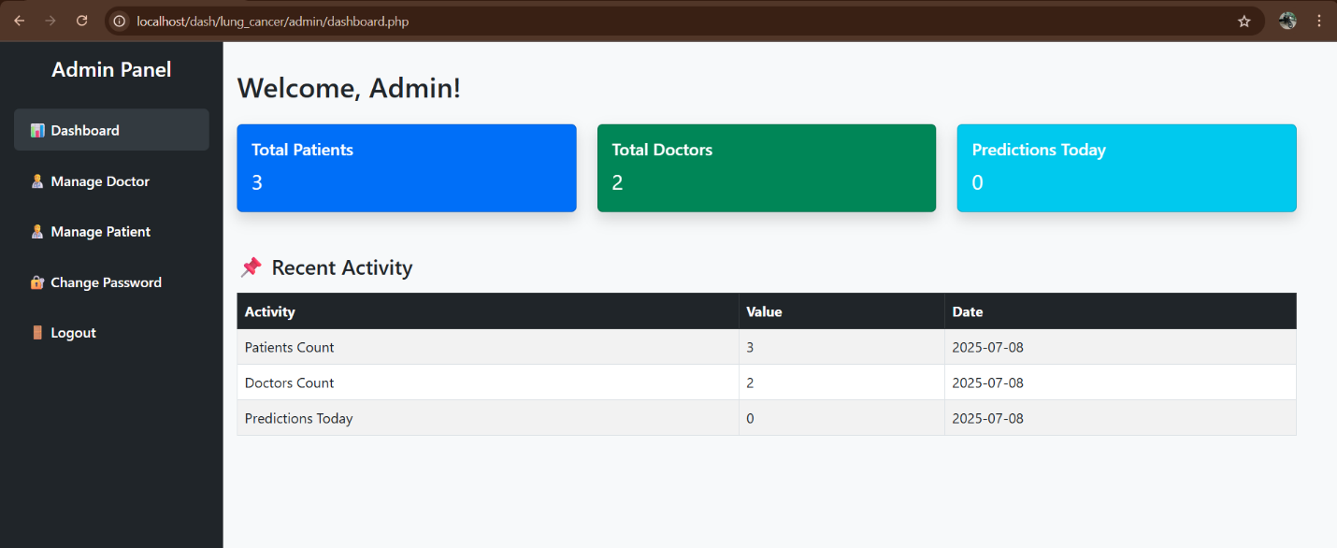

MANAGE DOCTOR
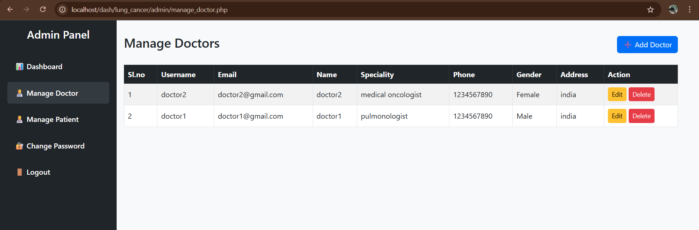

ADD NEW DOCTOR
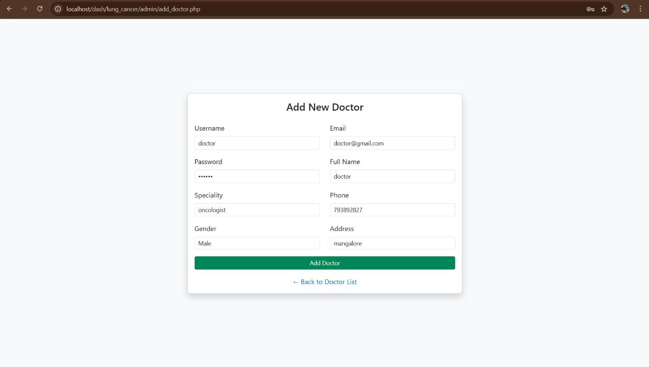

EDIT DOCTOR
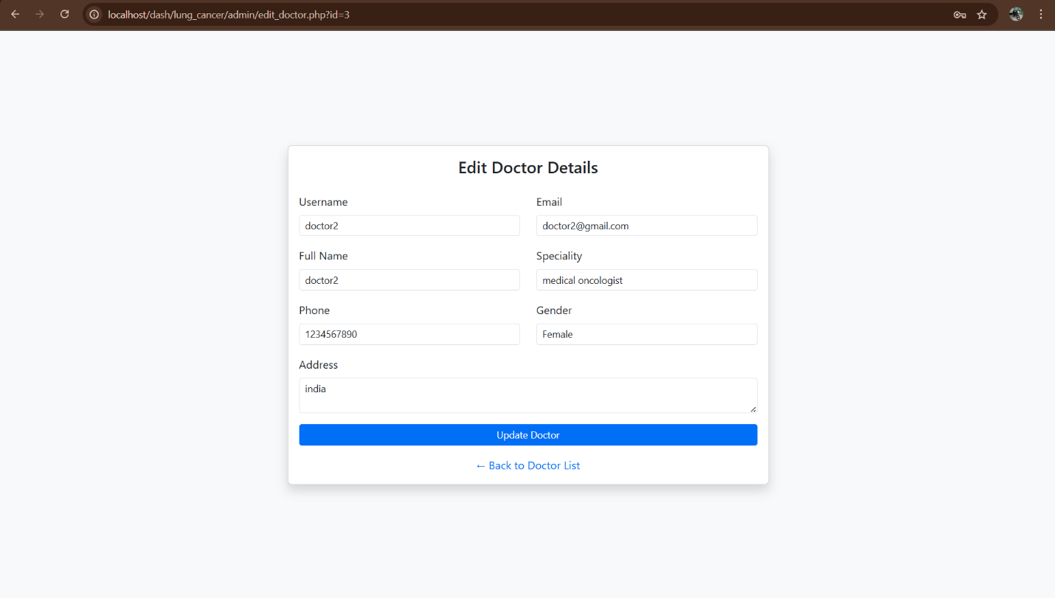

MANAGE PATIENT
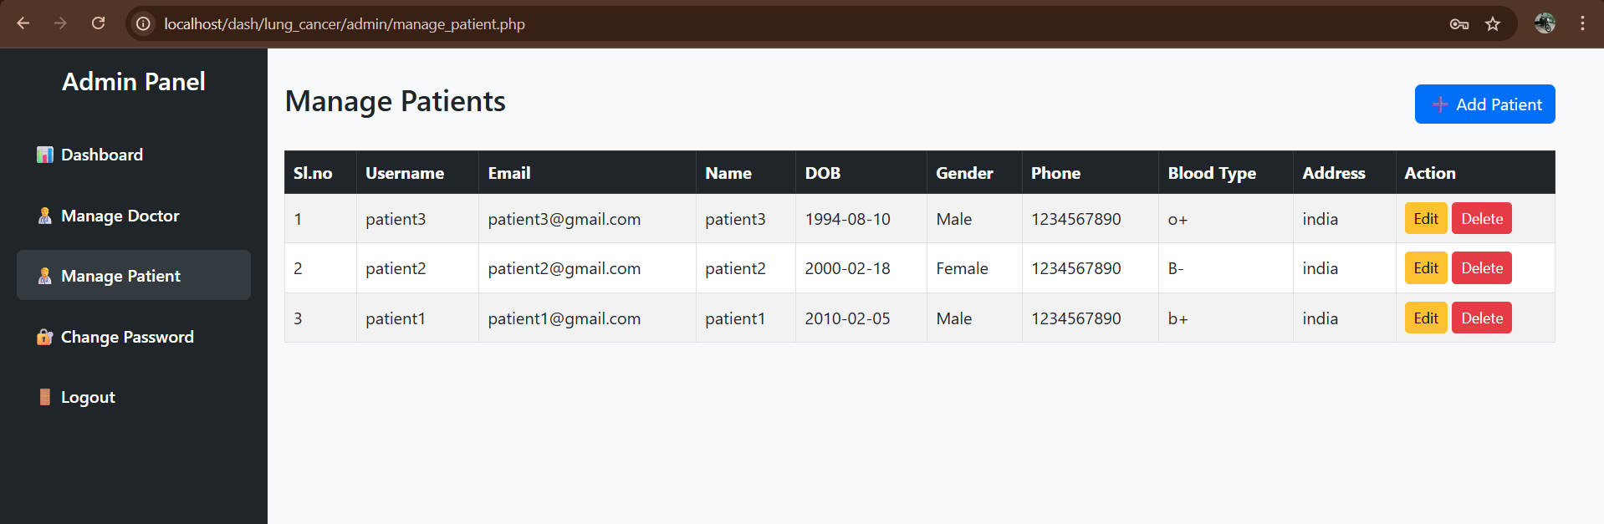

ADD NEW PATIENT
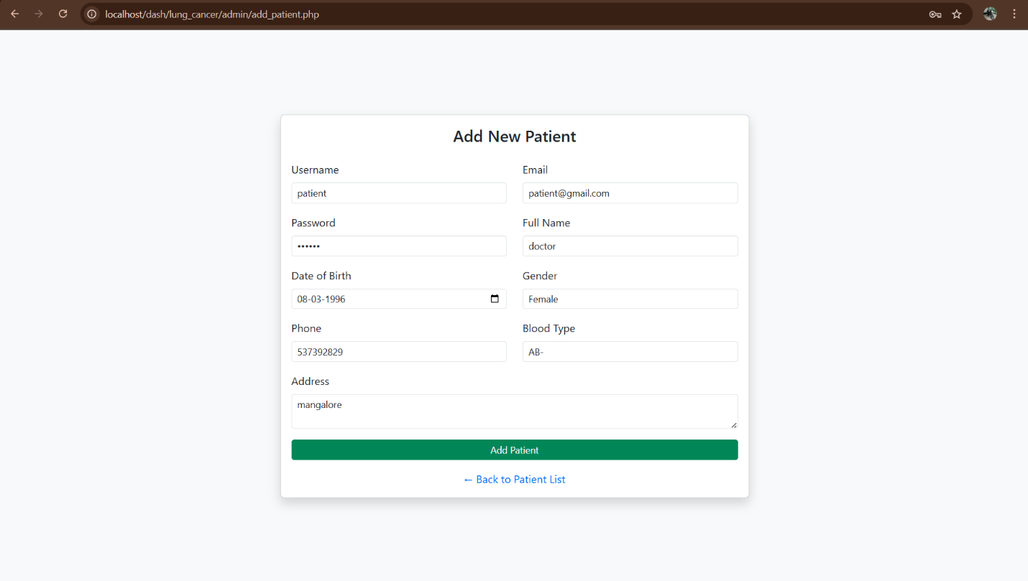

EDIT PATIENT
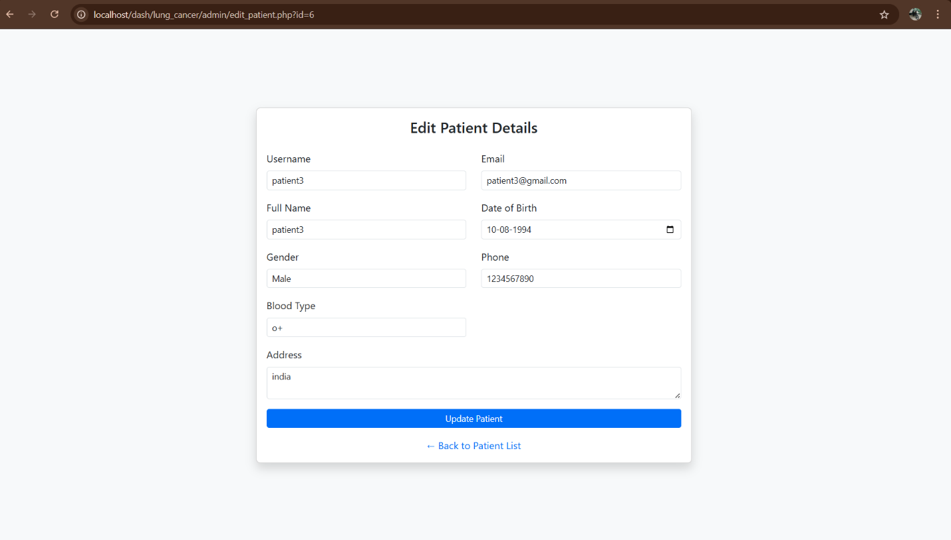
CHANGE PASSWORD
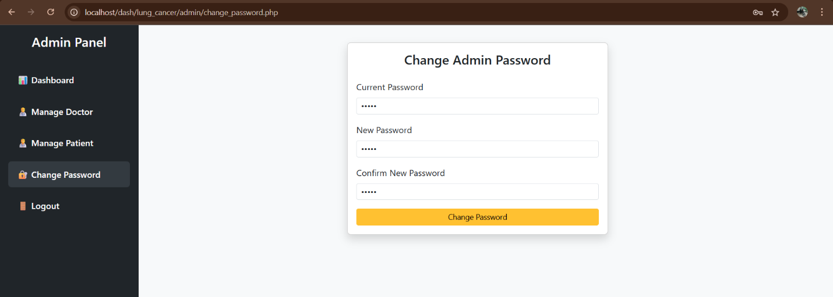

DOCTOR DASHBOARD
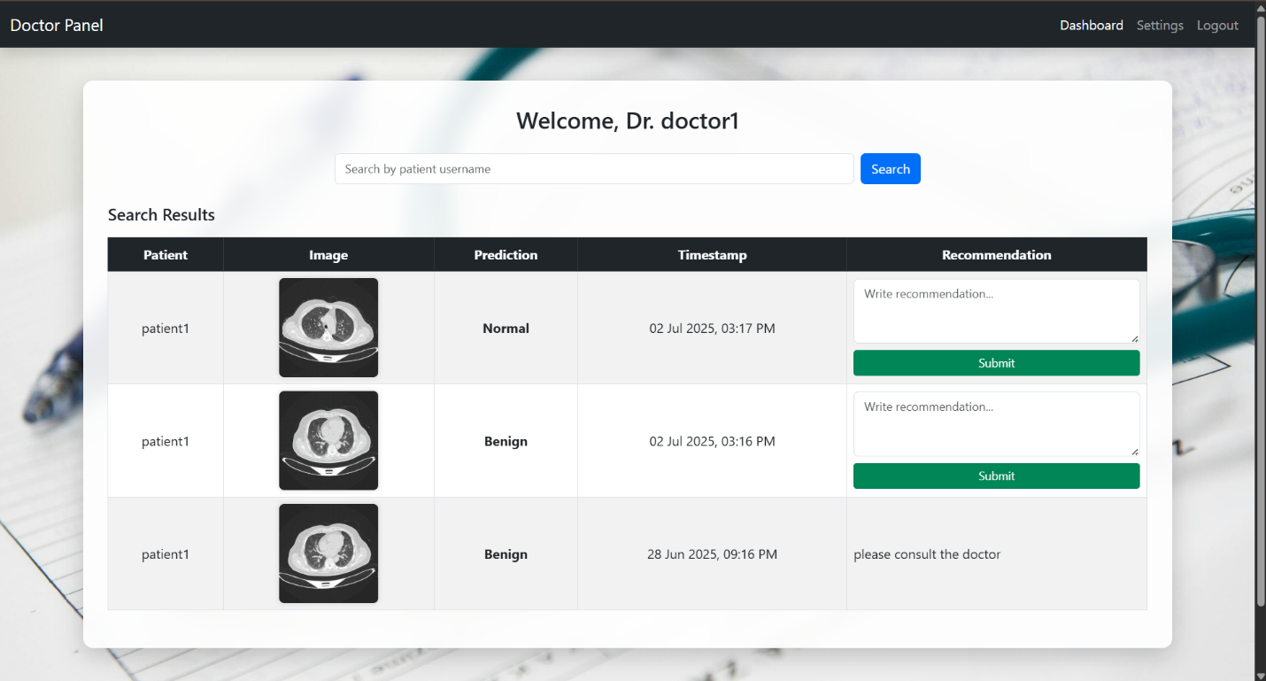

DOCTOR SETTINGS
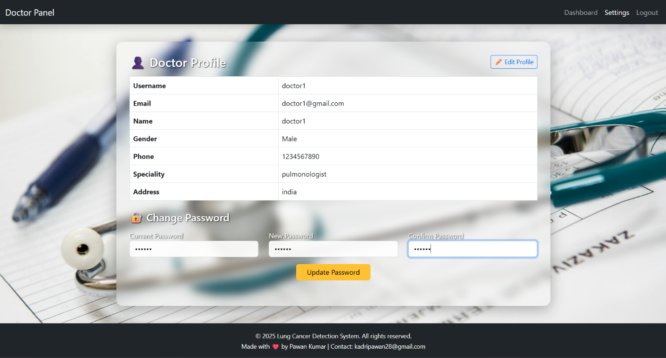

EDIT PROFILE
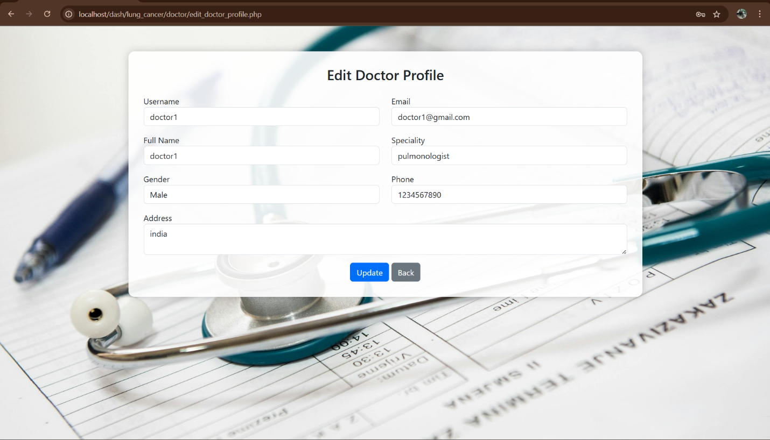

PATIENT DASHBOARD
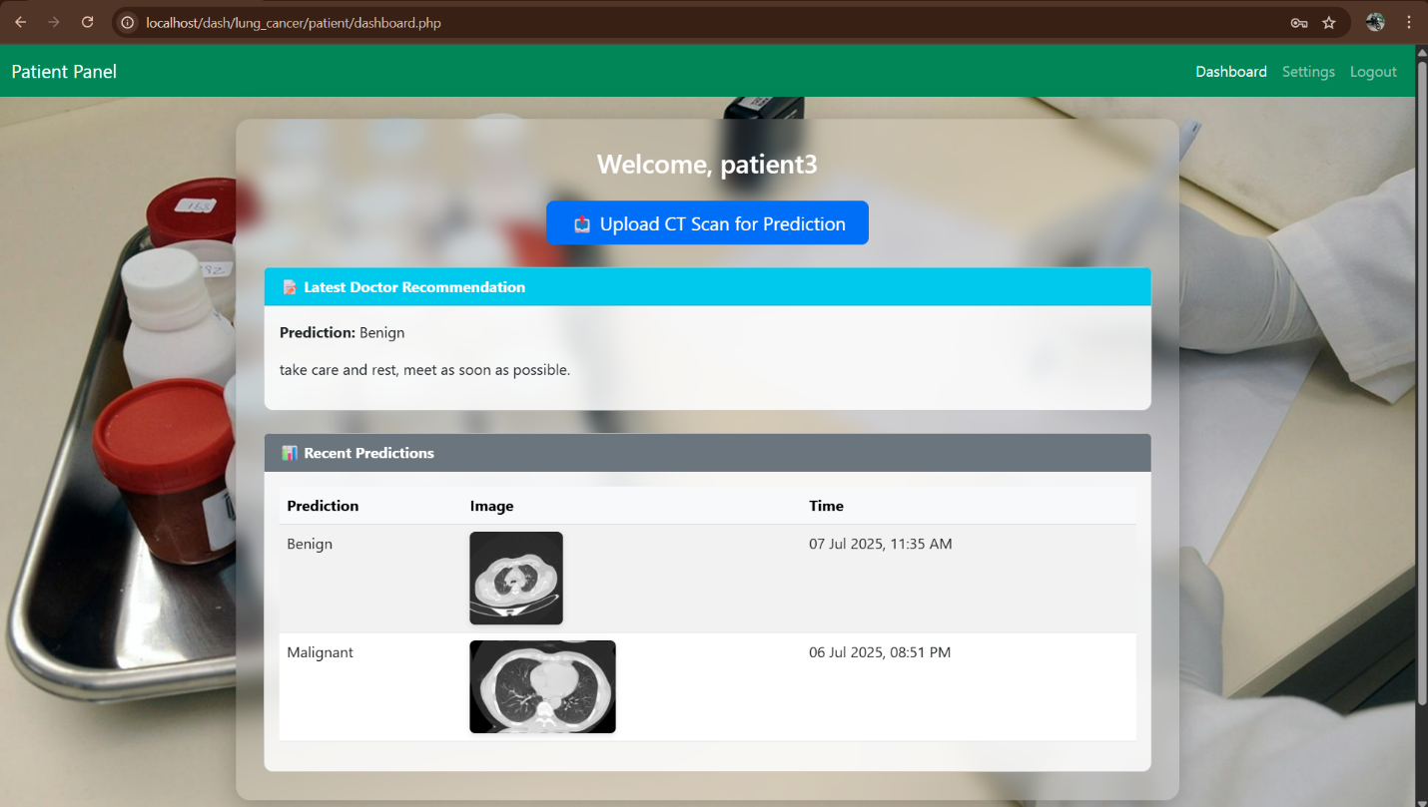

PATIENT PREDICTION
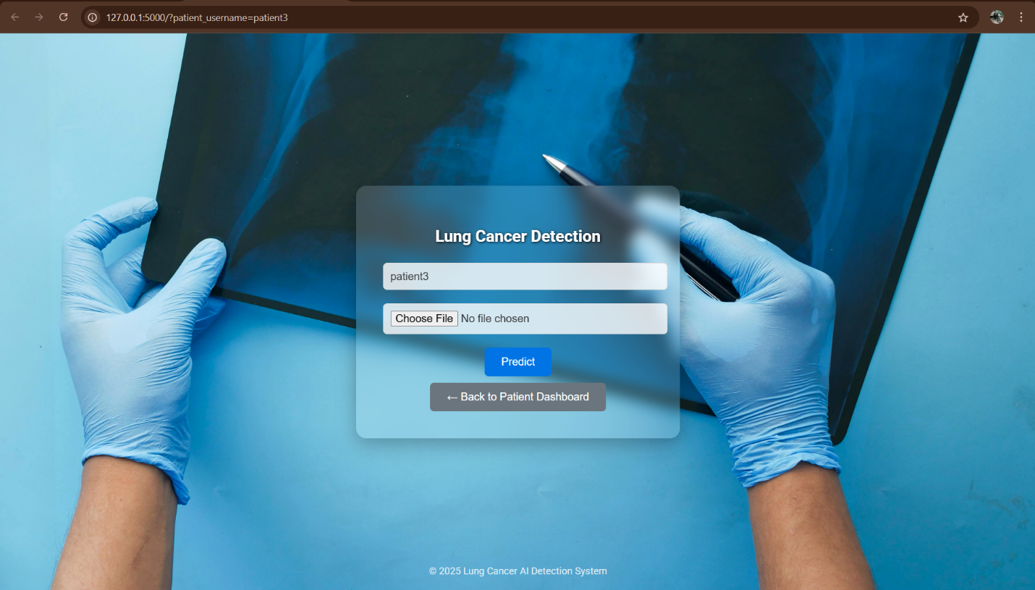
BENIGN CASE PREDICTION RESULT
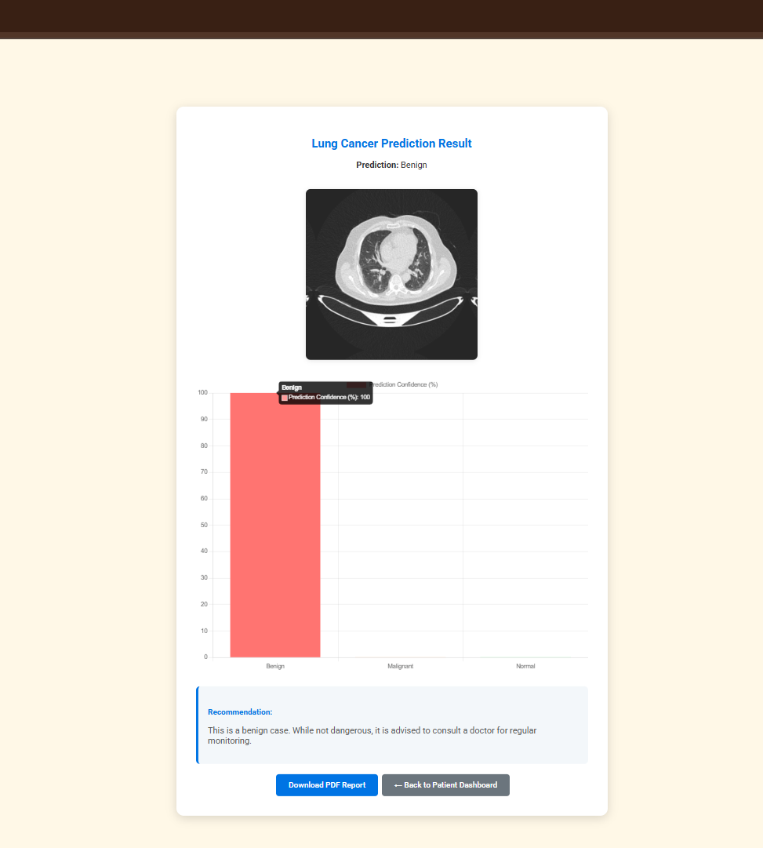

MALIGNANT CASE PREDICTION RESULT
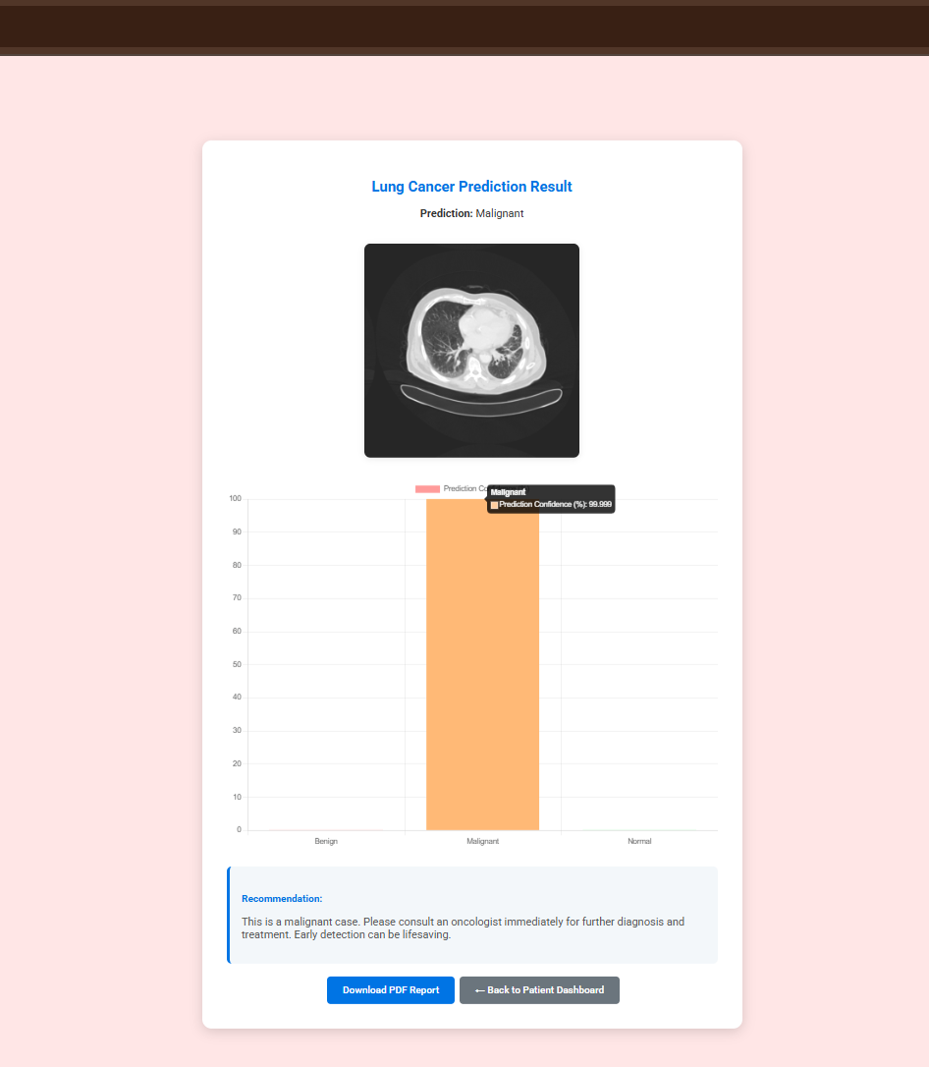

NORMAL CASE PREDICTION RESULT
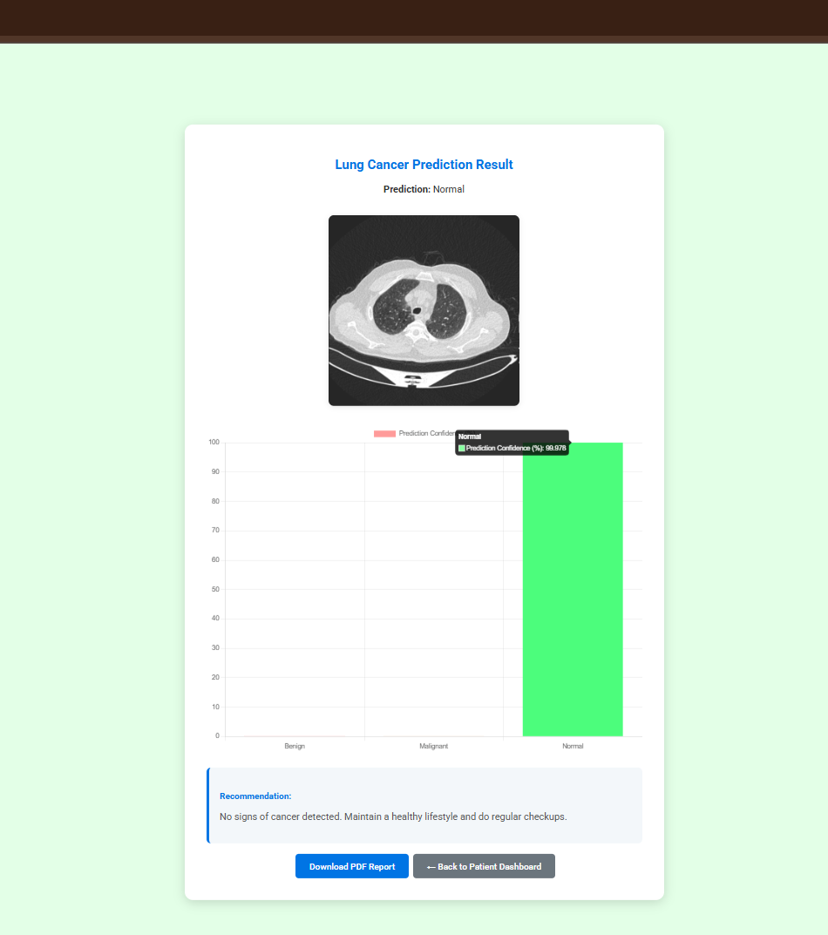

PATIENT SETTINGS
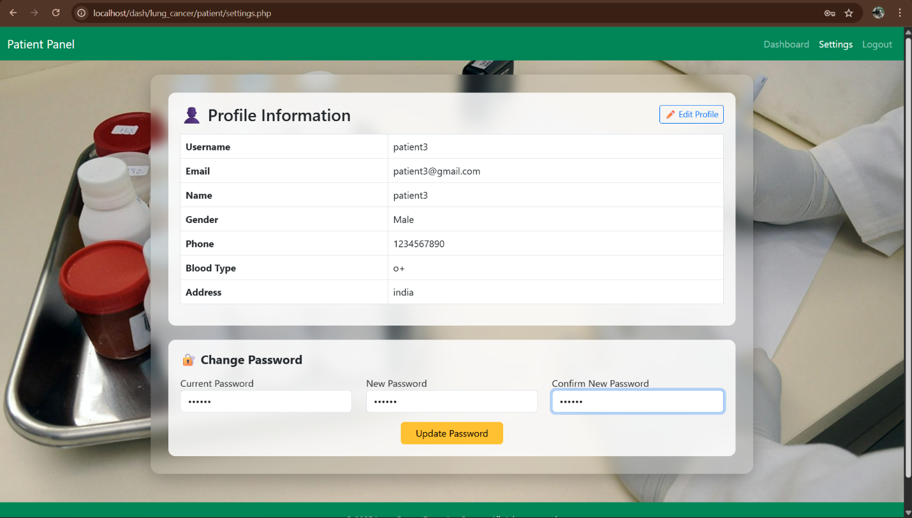

EDIT PROFILE
